1. What will be the output of 'seclist' in print commands of below code?

mylist = range(4)

seclist = mylist

print seclist

mylist.append(4)

print seclist

seclist = mylist[:]

print seclist

mylist.append(5)

print seclist

**Output:**

seclist 🡺 0, 1, 2, 3

seclist 🡺 0, 1, 2, 3, 4

seclist 🡺 0, 1, 2, 3, 4

seclist 🡺 0, 1, 2, 3, 4, 5

2. What is the output of following code:

def f(n):

for x in range(n):

yield x**3

for x in f(6):

print x

**Ans:**

0

1

8

27

64

125

3. Write a program to receive a string from keyboard and check if the string has two 'e' in the characters.

If yes return True else False

**Code:**

a=input("Enter a word or string:")

if (a.count("e")>=2):

print("True")

else:

print("False")

**Output:**

Enter a word or string: Balajeee

True

Enter a word or string: Hello

False

4. What is the output of following code:

counter = 1

def dolots(count):

global counter

for i in (1, 2, 3):

counter = count + i

print dolots(4)

print counter

**Output:**

None

7

5. Write a code to read the data from input file called input.txt and count the number of characters per line, number of words per line and write these into output file called as output.txt

**Code:**

file_read = open('C:/Users/Balaji.B.R/Desktop/textfile.txt', 'r')

file_write = open('C:/Users/Balaji.B.R/Desktop/optextfile.txt', 'w')

c = 1

for i in file_read:

c+=1

write = ["The number of characters & words in the line "+ str(c) + " is " + (str(len(i)) +" & "+ (str(len(i.split())))) + "\n"]

file_write.writelines(write)

file_write.close()

**Output:**

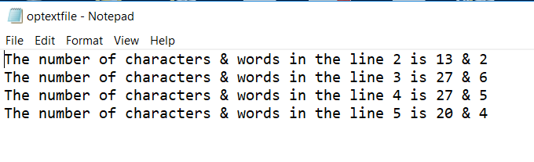

1. Create 3 Lists ( list1,list2,list3) with numbers and perform following operations

a) Create Maxlist by taking 2 maximum elements from each list.

b) Find average value from all the elements of Maxlist.

c) Create a MinlIst by taking 2 minimum elements from each list

d) Find the average value from all the elements of Minlist

@author: Balaji.B.R

"""

def maxlistfn(a):

#for len(a) in a:

a.sort()

a.reverse()

def minlistfn(a):

a.sort()

#Create 3 Lists ( list1,list2,list3) with numbers

list1 = [9, 1, 7, 3, 5]

list2 = [4, 10, 6, 2, 8]

list3 = [20, 40, 10, 30 , 50]

max_list = []

min_list = []

#Calling Maximum list function to sort the list

maxlistfn(list1)

maxlistfn(list2)

maxlistfn(list3)

#2 values from each list is being added to Maxlist

max_list = list1[:2] + list2[:2] + list3[:2]

max_list.sort()

print("Maxlist by taking 2 maximum elements from each list ", max_list)

#average of maxlist calculation

count = len(max_list)

avg = sum(max_list)/count

print("Average of Maxlist is : ", round(avg, 2))

#Calling Minimum list function to sort the list

minlistfn(list1)

minlistfn(list2)

minlistfn(list3)

#2 values from each list is being added to Minlist

min_list = list1[:2] + list2[:2] + list3[:2]

min_list.sort() #sort the list to have better look

print("Minlist by taking 2 minimum elements from each list", min_list)

#Average of minimum list calculation

count1 = len(max_list)

avg1 = sum(max_list)/count1

print("Average of Minlist is : ", round(avg1, 2))

**Output:**

Maxlist by taking 2 maximum elements from each list [7, 8, 9, 10, 40, 50]

Average of Maxlist is : 20.67

Minlist by taking 2 minimum elements from each list [1, 2, 3, 4, 10, 20]

Average of Minlist is : 20.67

1. **Write program to convert prefix/net mask to IP eg: input:16 output: 255.255.0.0**

**Coding:**

# @author: Balaji.B.R

def iptomask(len):

mask = ''

if not isinstance(len,int) or len<0 or len>32:

print("Enter correct Subnet Length")

else:

for i in range(4):

if len > 7:

mask+='255.'

else:

dec = 255 - (2**(8-len)-1)

mask+=str(dec)+'.'

len-=8

if len < 0:

len = 0

return mask[:-1]

for len in range(16,-1,-1):

#print(len)

print(len, iptomask(len))

**Output:**

16 255.255.0.0

15 255.254.0.0

14 255.252.0.0

13 255.248.0.0

12 255.240.0.0

11 255.224.0.0

10 255.192.0.0

9 255.128.0.0

8 255.0.0.0

7 254.0.0.0

6 252.0.0.0

5 248.0.0.0

4 240.0.0.0

3 224.0.0.0

2 192.0.0.0

1 128.0.0.0

0 0.0.0.0

1. Create a suitable data construct to read the data from an xml document as shown below:

<bookstore shelf="New Arrivals">

<book category="COOKING">

<title lang="en">Everyday Italian</title>

<author>Giada De Laurentiis</author>

<year>2005</year>

<price>30.00</price>

</book>

<book category="CHILDREN">

<title lang="en">Harry Potter</title>

<author>J K. Rowling</author>

<year>2005</year>

<price>29.99</price>

</book>

<book category="WEB">

<title lang="en">Learning XML</title>

<author>Erik T. Ray</author>

<year>2003</year>

<price>39.95</price>

</book>

</bookstore>

**Coding:**

import xml.dom.minidom

#open XML Document using minidom parser

DOMTree = xml.dom.minidom.parse("C:/Users/Balaji.B.R/Desktop/book.xml")

collection = DOMTree.documentElement

if collection.hasAttribute("shelf"):

print("Book Store: ",collection.getAttribute("shelf"))

# Get all the Books in the category collection

books = collection.getElementsByTagName("book")

# Print detail of each Book.

for book in books:

print("*****Books*****")

if book.hasAttribute('category'):

print("Category: ",book.getAttribute("category"))

print("Title: ",book.getElementsByTagName("title")[0].childNodes[0].data)

print("Author: ",book.getElementsByTagName("author")[0].childNodes[0].data)

print("Year: ",book.getElementsByTagName("year")[0].childNodes[0].data)

print("Price: ",book.getElementsByTagName("price")[0].childNodes[0].data)

**Output:**

Book Store: New Arrivals

*****Books*****

Category: COOKING

Title: Everyday Italian

Author: Giada De Laurentiis

Year: 2005

Price: 30.00

*****Books*****

Category: CHILDREN

Title: Harry Potter

Author: J K. Rowling

Year: 2005

Price: 29.99

*****Books*****

Category: WEB

Title: Learning XML

Author: Erik T. Ray

Year: 2003

Price: 39.95

1. Create a suitable object type and check for file size of 0 bytes of the directory contents as shown below

02/15/2016 10:49 PM 962 switchfinal.py

02/15/2016 10:49 PM 943 switchfinal.py.bak

01/27/2016 11:46 AM 15 t.py

03/31/2016 12:39 PM 840 t1.py

01/25/2016 10:34 AM 2,407 tc1.py

02/14/2017 09:13 AM 0 teat.py

03/15/2016 05:52 PM 5 tes.py

**Coding:**

import os

def zero_filesize(directory, size):

for root, _, files in os.walk(directory):

for filename in files:

filepath = os.path.join(root,filename)

if os.path.getsize(filepath) == size:

print(filename)

print("Zero KB Files in the directory: C:\\Users\\Balaji.B.R\\Downloads")

zero_filesize("C:/Users/Balaji.B.R/Downloads", 0)

**Output:**

Zero KB Files in the directory: C:\Users\Balaji.B.R\Downloads

New Text Document.txt

Wipro_LSAProcess (1).pdf

Wipro_LSAProcess (2).pdf

Wipro_LSAProcess.pdf

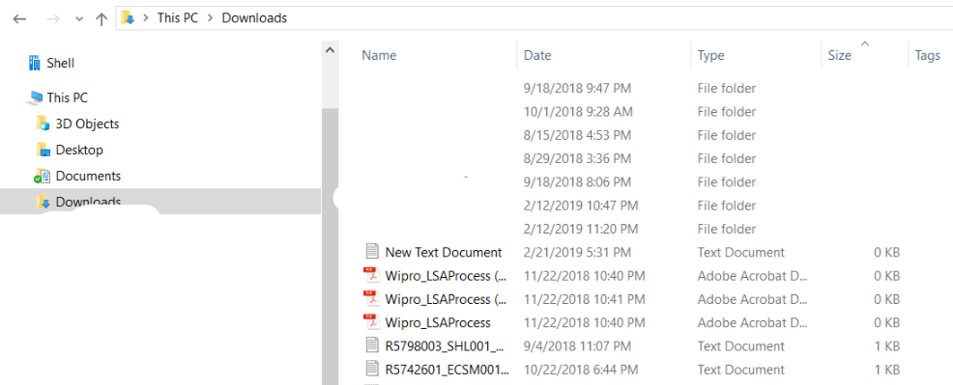

10.Create a suitable object type to eliminate the duplicate elements

**Coding:**

#Create a suitable object type to eliminate the duplicate elements

a = [1,2,3,1,2,3,4,7,9,6,7,8,7,6,5,45,65,78,78,98,65,45,4,5,8]

unique_set= set(a)

list_type = list(unique_set) #conversion of set to list

print(list_type)

**Output:**

[1, 2, 3, 4, 5, 6, 7, 8, 9, 65, 98, 45, 78]